**Sakshi Kathote – (002114111)**

**Program Structures & Algorithms Summer 2021 Assignment No. 3**

**Task 1 :**

(a) Implement height-weighted Quick Union with Path Compression. For this, you will flesh out the class UF_HWQUPC. All you have to do is to fill in the sections marked with // TO BE IMPLEMENTED ... // ...END IMPLEMENTATION.

(b) Check that the unit tests for this class all work. You must show "green" test results in your submission (screenshot is OK).

**Output :**

UF_HWQUPC_Test

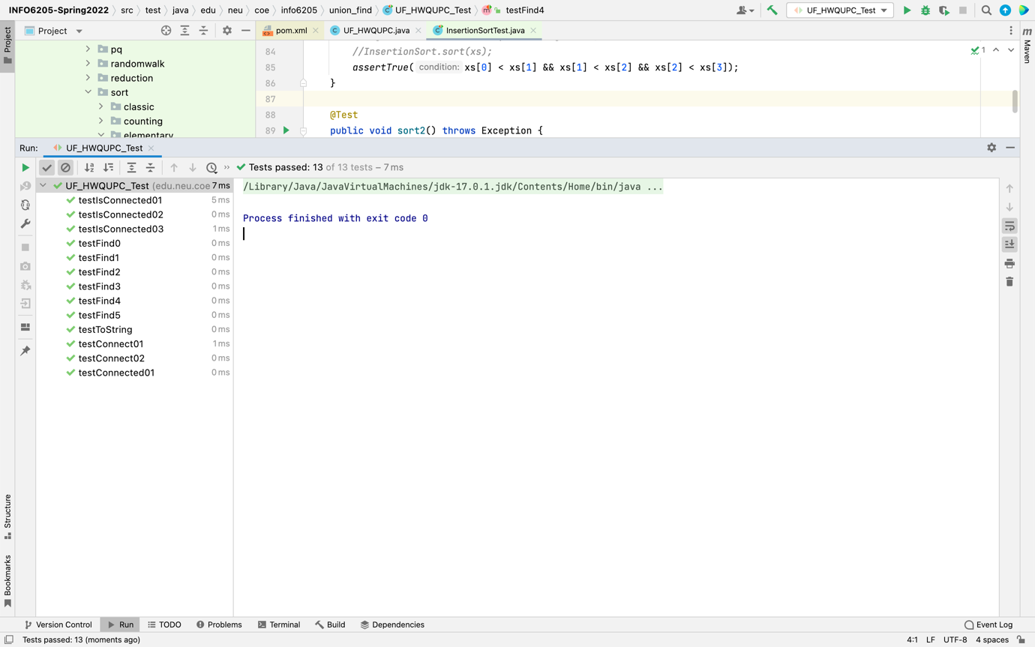

**Task 2:**

Using your implementation of UF_HWQUPC, develop a UF ("union-find") client

that takes an integer value n from the command line to determine the number of

"sites." Then generates random pairs of integers between 0 and n-1, calling

connected() to determine if they are connected and union() if not. Loop until all

sites are connected then print the number of connections generated. Package your

program as a static method count() that takes n as the argument and returns the number of connections; and a main() that takes n from the command line, calls

count() and prints the returned value. If you prefer, you can create a main program

that doesn't require any input and runs the experiment for a fixed set of n values.

Show evidence of your run(s).

Output:

UF_HWQUPC_Client

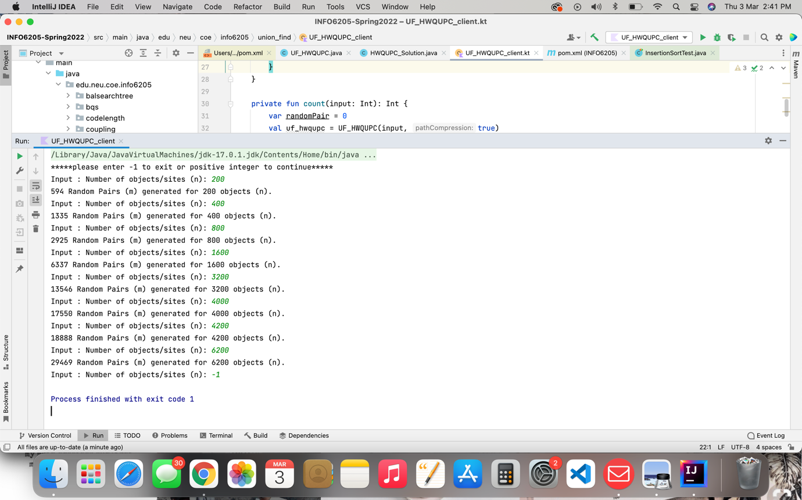

**Task 3**

Determine the relationship between the number of objects (*n*) and the number of pairs (*m*) generated to accomplish this (i.e. to reduce the number of components from *n* to 1). Justify your conclusion in terms of your observations and what you think might be going on.

**Evidence to support the conclusion**

|  |  |  |
| --- | --- | --- |
| Column 1 | Column 2 | Column 3 |
| number of objects(n) | number of connections(m) | Approx to n* In (n)/2 |
| 50 | 115 | 97.75 |
| 100 | 259 | 230 |
| 200 | 594 | 529 |
| 400 | 1335 | 1198 |
| 800 | 2925 | 2672 |
| 1600 | 6337 | 5896 |
| 3200 | 13546 | 12912 |
| 4000 | 17550 | 16580 |
| 4200 | 18888 | 17514 |
| 6200 | 29469 | 27063 |

**Graphical Representation**

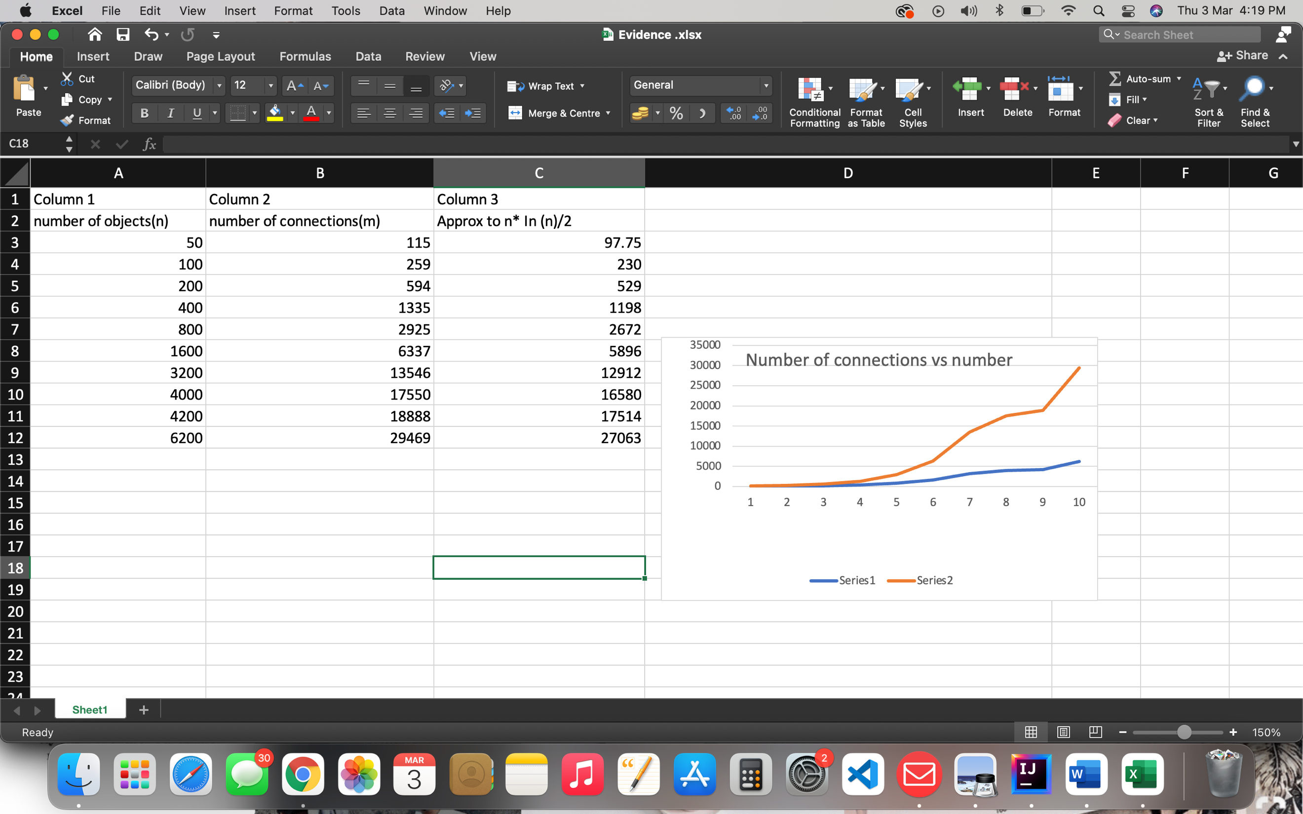

**Conclusion**

1. From the number of experiments carried out It is observed that, relationship between the number of objects (*n*) and the number of pairs (*m*) is ***m*** is equivalent to ***n* *ln(*n*)/2**. Evidence provided above clearly shows that, cloumn2 and column 3 are equivalent.
2. In theory, Weight Quick-Union with Path Compression is not quite linear.
3. In practice, Weight Quick-Union with Path Compression is linear.